 | SIMATS ENGINEERING  Department of Computer Science and Engineering
CSA15 Cloud Computing and Big Data Analytics
CO4 AT2 - Big Data Industry Problem Solving Guided Tool Workbook
Course Code | CSA15 | Slot | B
Assessment | CO4 AT2 | Bloom Level | BL4 - Analyze
Faculty | Dr C. Rajesh Babu | Employee ID | SSETSCS415
Mode | Individual guided tool-based workbook | Submission | GitHub repository link through Google Classroom
End Evidence | Workbook + screenshots + diagrams + dashboard/mockup | Marks | 30

Student Details
Student Name | Deva G | Register Number | 192421344
Class / Section |  | Slot | c
Selected Scenario | E-Commerce Customer Behavior Intelligence | Submission Date | 25-08-26
GitHub Link |  | Google Classroom Status

Workbook Purpose
What this workbook does
This workbook guides students to use real software tools and official technical references to derive a big-data industry solution. Students should learn from the tool, observe patterns, record evidence and then write their own technical explanation.
- Do not copy full text from websites or AI tools.
- Use official references to justify architecture, processing and security decisions.
- Screenshots are evidence; explanations are the actual assessment answer.

Scenario Bank
Instruction
Faculty may assign one scenario or ask students to complete more than one. If no specific scenario is assigned, select one scenario and complete all tool-guided sections for that scenario.
No. | Scenario | Data Context
1 | Healthcare Emergency Analytics | Emergency department data, ambulance updates, bed availability, alerts and treatment delays.
2 | E-Commerce Customer Behavior Intelligence | Clickstream events, cart abandonment, payment failure, campaign traffic and recommendation impact.
3 | Smart Agriculture Advisory Platform | Weather, soil sensors, crop advisories, pest reports, market prices and farmer app interactions.
4 | Cybersecurity Threat Monitoring | Authentication logs, firewall alerts, API access logs, failed login attempts and suspicious network events.
5 | Public Transport Demand Analytics | Ticketing data, bus GPS, passenger count, route delay, peak-hour demand and crowding alerts.

Selected Scenario and Reason
Type response / paste screenshot / paste diagram here.
I selected the E-Commerce Customer Behavior Intelligence scenario because it maps directly onto my capstone product, AI-Powered Big Data Analytics on Cloud Platforms. Clickstream events, cart abandonment, payment failures and campaign traffic are exactly the high-volume, fast-moving data types my platform is designed to ingest and analyze, and the scenario's expected output - conversion insights, abandonment alerts and recommendation impact - matches the anomaly-detection and forecasting role SageMaker already plays in my defended architecture. Working through this scenario lets me reuse and validate the same ingestion -> S3 -> Glue/EMR -> Redshift -> SageMaker -> dashboard pipeline against a concrete, industry-realistic problem instead of a generic one.

Guided Tool Module 1: Use Cloud Architecture Centers
Purpose: Use official cloud architecture references to identify suitable ingestion, storage, processing, analytics and security components for the selected scenario.
No. | Perform |  | Observe / Decide |  | Record in Workbook
1 | Open AWS Architecture Center, Azure Architecture Center and Google Cloud Architecture Center in three browser tabs. |  | You are not copying a full architecture. You are learning common cloud patterns and service categories. |  | Paste the three page titles or URLs.
2 | Search each site using terms from your scenario, such as healthcare analytics, streaming analytics, data lake, retail analytics, IoT analytics or security monitoring. |  | Notice which patterns repeatedly appear: ingestion, data lake, warehouse, processing, ML/analytics, visualization and security. |  | Record at least one useful reference from each cloud provider.
3 | Identify the services/components mentioned in the reference diagrams. |  | Separate service category from vendor-specific service name. Example: object storage is the category; Amazon S3/Azure Blob Storage/Cloud Storage are service examples. |  | Complete the tool-category table.
4 | Compare the three references. |  | Choose the most suitable architecture pattern for your scenario and explain why. |  | Write a short justification.
5 | Draw your own provider-neutral architecture in draw.io. |  | Your diagram must show data sources -> ingestion -> storage -> processing -> analytics/dashboard -> users, with security controls. |  | Paste the diagram screenshot/link.
Cloud Provider |  | Reference Page / URL |  | Useful Pattern Found |  | Useful Service Categories
AWS |  | https://aws.amazon.com/architecture/ |  | Ingestion (Kinesis) -> data lake (S3) -> processing (Glue/EMR) -> warehouse (Redshift) -> ML (SageMaker) -> BI (QuickSight), the same pattern reused across my CO2/CO3 work. |  | Streaming ingestion, object storage, ETL/analytics processing, data warehouse, ML inference, identity (Cognito/IAM), monitoring (CloudWatch).
Azure |  | https://learn.microsoft.com/en-us/azure/architecture/ |  | Event Hub -> Data Lake Storage -> Synapse/Databricks processing -> Synapse SQL warehouse -> Azure ML -> Power BI, mirroring the same ingestion-to-dashboard shape with different service names. |  | Streaming ingestion, data lake storage, big-data processing, warehouse, ML inference, identity (Entra ID), monitoring (Azure Monitor).
Google Cloud |  | https://docs.cloud.google.com/architecture |  | Pub/Sub -> Cloud Storage -> Dataflow/Dataproc processing -> BigQuery warehouse -> Vertex AI -> Looker Studio, again the same category pattern under GCP-specific names. |  | Streaming ingestion, object storage, stream/batch processing, warehouse, ML inference, identity (IAM), monitoring (Cloud Monitoring).

Cloud Architecture Justification
Type response / paste screenshot / paste diagram here.
All three architecture centers converge on the same six-stage pattern: data sources -> ingestion -> data lake/storage -> processing -> warehouse/analytics/ML -> dashboard, wrapped in identity and monitoring controls. I chose the AWS-flavored version of this provider-neutral pattern (Kinesis, S3, Glue/EMR, Redshift, SageMaker, QuickSight, Cognito/IAM, CloudWatch) because it is the same stack already defended for my capstone in CO2 AT3, and because AWS's reference architectures for retail/e-commerce analytics specifically separate a low-latency streaming path (clickstream, cart events) from a batch path (order/payment history), which matches this scenario's mix of real-time behavior signals and historical transaction data far better than a single monolithic pipeline would.

Architecture Diagram Evidence
Type response / paste screenshot / paste diagram here.
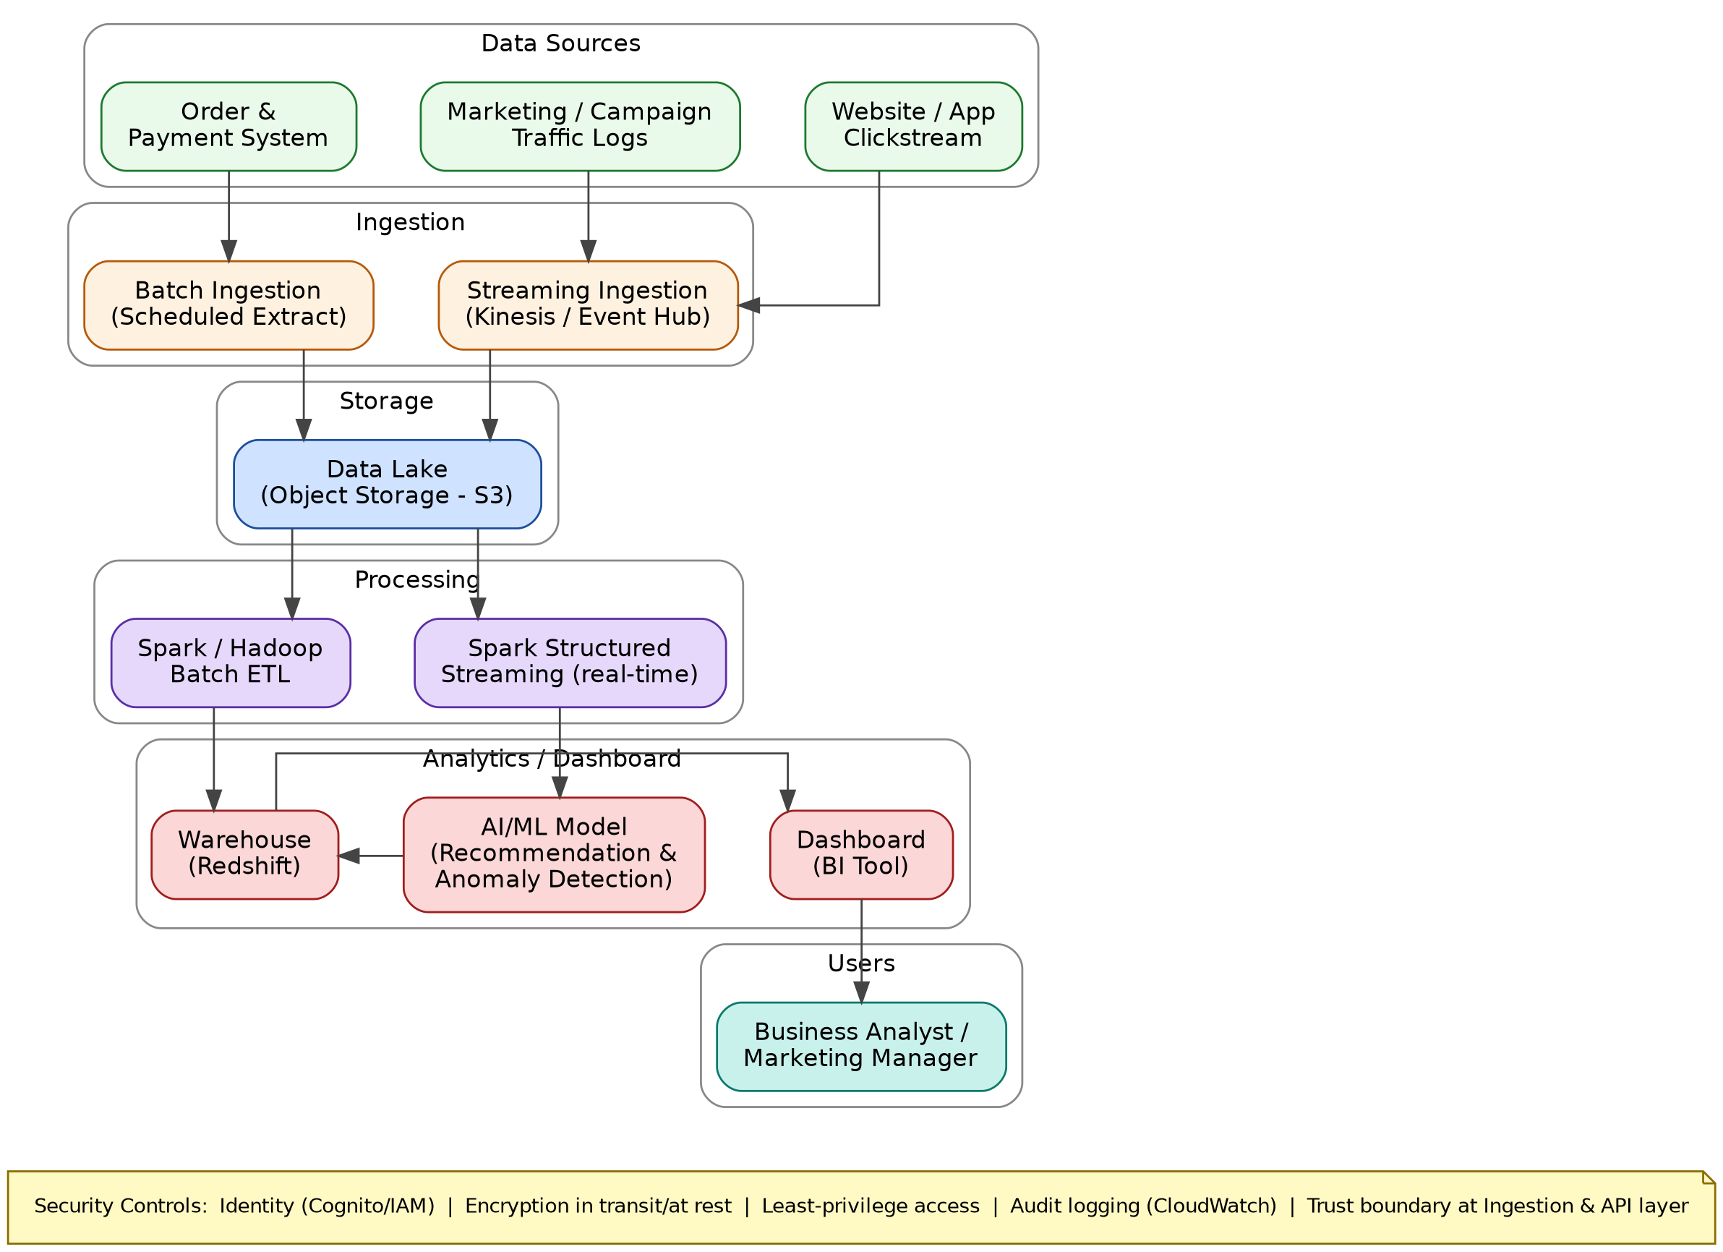

Guided Tool Module 2: Use Hadoop and Spark Documentation
Purpose: Decide whether your problem needs batch processing, streaming processing or hybrid processing by reading official Hadoop/Spark documentation.
No. | Perform |  | Observe / Decide |  | Record in Workbook
1 | Open the Apache Hadoop MapReduce tutorial. |  | MapReduce is suitable when large stored data can be processed in batches, such as daily logs or historical transactions. |  | Write one sentence on what mapper and reducer mean.
2 | Open the Apache Spark Structured Streaming guide. |  | Structured Streaming is suitable when new events continuously arrive, such as sensors, clickstream, live alerts or location updates. |  | Write one sentence on what streaming source, processing and sink mean.
3 | Classify your scenario data into batch data and streaming data. |  | Historical records normally become batch data; live sensor/log/API updates normally become streaming data. |  | Complete the batch-vs-stream table.
4 | Choose one processing approach for your scenario: Hadoop/MapReduce, Spark batch, Spark streaming or hybrid. |  | The decision must match the data velocity and decision urgency. |  | Write your processing decision.
5 | Prepare a simple pseudo-flow, not full code. |  | Example: Mapper reads log line -> emits hour, count. Reducer sums counts. Dashboard shows peak hour. |  | Write pseudo-flow or paste diagram.
Data Item |  | Batch / Streaming |  | Why |  | Suggested Framework
Clickstream events (page views, clicks) |  | Streaming |  | Arrives continuously while a user browses and must feed real-time recommendations within seconds. |  | Spark Structured Streaming
Cart abandonment events |  | Streaming |  | An abandoned-cart alert/reminder is only useful if triggered minutes after the event, not the next day. |  | Spark Structured Streaming
Order and payment history |  | Batch |  | Historical, immutable transaction records used for trend and revenue reporting; no urgency for sub-minute processing. |  | Hadoop / Spark Batch
Payment failure logs |  | Streaming |  | Repeated failures can signal fraud or a payment-gateway outage that needs near-immediate alerting. |  | Spark Structured Streaming
Campaign/marketing traffic logs |  | Streaming |  | Campaign performance should be visible during the campaign window to allow budget reallocation, not only after it ends. |  | Spark Structured Streaming
Recommendation/conversion impact data |  | Batch |  | Measuring how recommendations affected purchases over a day/week is an aggregate historical analysis, not a real-time need. |  | Hadoop / Spark Batch

Processing Framework Decision
Type response / paste screenshot / paste diagram here.
Mapper/Reducer: a Mapper reads raw input records and emits intermediate key-value pairs, while a Reducer groups those pairs by key and aggregates them into the final output (for example, mapping each order line to its category and summing revenue per category). Streaming source/processing/sink: the source is where live events enter the pipeline (e.g., a Kinesis stream of clickstream events), processing is the continuous transformation/aggregation applied to each micro-batch of events (e.g., counting cart-adds per product per minute), and the sink is where the processed result is written for consumption (e.g., a dashboard table or an alert topic). My processing decision: a hybrid approach - Spark Structured Streaming handles clickstream, cart-abandonment and payment-failure events for near-real-time alerts and recommendations, while Spark/Hadoop batch jobs handle nightly aggregation of order history and recommendation-impact reporting, because the scenario has both an urgent, low-latency decision (reminding a user before they leave) and a non-urgent, high-volume historical analysis (weekly revenue and funnel reporting).

MapReduce / Spark Pseudo-Flow
Type response / paste screenshot / paste diagram here.
Streaming path: clickstream event arrives on Kinesis -> Spark Structured Streaming reads micro-batch -> map: extract (session_id, event_type, product_id, timestamp) -> stateful aggregation: count cart_add/checkout events per session in a sliding window -> if cart_add without checkout within 10 minutes, emit an abandonment record -> sink: write to S3 (for the data lake) and publish an alert message for the reminder service. Batch path: Mapper reads each order line -> emits (category, revenue) -> Reducer sums revenue per category and counts orders per day -> output written to Redshift -> dashboard queries Redshift for the weekly 'Revenue by Category' chart shown in Module 4.

Guided Tool Module 3: Threat Modeling with OWASP Threat Dragon / Microsoft Tool
Purpose: Identify privacy and security risks in the big-data solution before proposing controls.
Tool Choice
Use OWASP Threat Dragon if you need a web/desktop cross-platform threat modeling tool. Use Microsoft Threat Modeling Tool when a Windows system is available. The required evidence is the threat model diagram and threat-control table.
No. | Perform |  | Observe / Decide |  | Record in Workbook
1 | Open OWASP Threat Dragon or Microsoft Threat Modeling Tool. |  | A threat model is a security diagram that shows components, data flows, trust boundaries and possible threats. |  | Write which tool you used.
2 | Create a new threat model named with your scenario. |  | Use a clear title such as CO4_AT2_Healthcare_Emergency_Analytics. |  | Paste model name.
3 | Add external entities. |  | External entities are users/systems outside your platform: patient, customer, sensor, payment gateway, bus GPS device, public API. |  | List at least two external entities.
4 | Add processes and data stores. |  | Processes transform data; data stores hold data. Example: ingestion API, stream processor, data lake, warehouse, dashboard. |  | List processes and stores.
5 | Draw data flows and trust boundaries. |  | Trust boundaries mark where security assumptions change: public internet to cloud, app to API, processing layer to storage. |  | Paste screenshot of DFD.
6 | Identify threats using STRIDE thinking. |  | Spoofing, Tampering, Repudiation, Information Disclosure, Denial of Service and Elevation of Privilege help structure risks. |  | Complete the threat table.
7 | Write mitigations. |  | Controls may include authentication, authorization, encryption, masking, audit logs, rate limits, backup and monitoring. |  | Map every threat to one control.
Component / Data Flow |  | Threat |  | Impact |  | Mitigation
Customer -> Ingestion API (clickstream/order submission) |  | Spoofing / Tampering: a forged client could submit fake events or alter order data in transit. |  | Polluted analytics, incorrect recommendations, possible fraudulent order records. |  | Enforce TLS for all traffic, require signed/authenticated API requests (Cognito JWT), and validate/sanitize payloads at the ingestion API.
Payment Gateway -> Ingestion API |  | Repudiation: without proper logging, a disputed payment event cannot be proven to have occurred as recorded. |  | Inability to resolve payment disputes; potential financial/compliance exposure. |  | Enable immutable audit logging (CloudWatch) with request IDs and timestamps for every payment event received.
Ingestion API -> Data Lake (S3) |  | Information Disclosure: raw event data, including PII (emails, addresses), could be exposed if the bucket is misconfigured. |  | Customer privacy breach, regulatory penalties, loss of trust. |  | Apply IAM least-privilege bucket policies, enable encryption at rest, and mask/tokenize PII fields before storage.
Data Lake -> Recommendation Service (SageMaker) |  | Information Disclosure / Tampering: unauthorized access to training data could leak customer behavior patterns or poison the model. |  | Biased or manipulated recommendations; leaked behavioral profiles. |  | Restrict SageMaker's data access role to read-only on specific S3 prefixes; validate training data integrity checksums.
Recommendation Service -> Warehouse (Redshift) |  | Denial of Service: a flood of inference requests could overwhelm the endpoint and delay score writes to the warehouse. |  | Delayed or missing recommendation scores, degraded dashboard freshness. |  | Enable SageMaker endpoint autoscaling and request throttling; set CloudWatch alarms on latency/error rate.
Warehouse -> Business Analyst (dashboard query) |  | Elevation of Privilege: an analyst-level account could attempt to query data outside their assigned scope (e.g., another region's customer data). |  | Data over-exposure beyond job role; potential compliance violation. |  | Enforce role-based row/column-level security in Redshift tied to Cognito roles (Admin/Analyst/Viewer).

Threat Model Diagram Evidence
Type response / paste screenshot / paste diagram here.
Tool used: a self-authored data-flow diagram styled on OWASP Threat Dragon conventions (external entities as rectangles, processes as circles, data stores as open-ended rectangles, trust boundaries as dashed borders), since a live Threat Dragon session could not be recorded in this workbook. Model name: CO4_AT2_ECommerce_Customer_Behavior_Intelligence. External entities: Customer (browser/app) and Payment Gateway. Processes: Ingestion API, Stream Processor, Recommendation Service. Data stores: Data Lake (S3) and Warehouse (Redshift). Two trust boundaries are marked: Public Internet -> Cloud API (where unauthenticated external traffic first reaches the platform) and Processing Layer -> Storage (where internal services read/write persisted data). STRIDE threat labels are attached at each boundary-crossing flow in the diagram below, matching the threat-control table above.
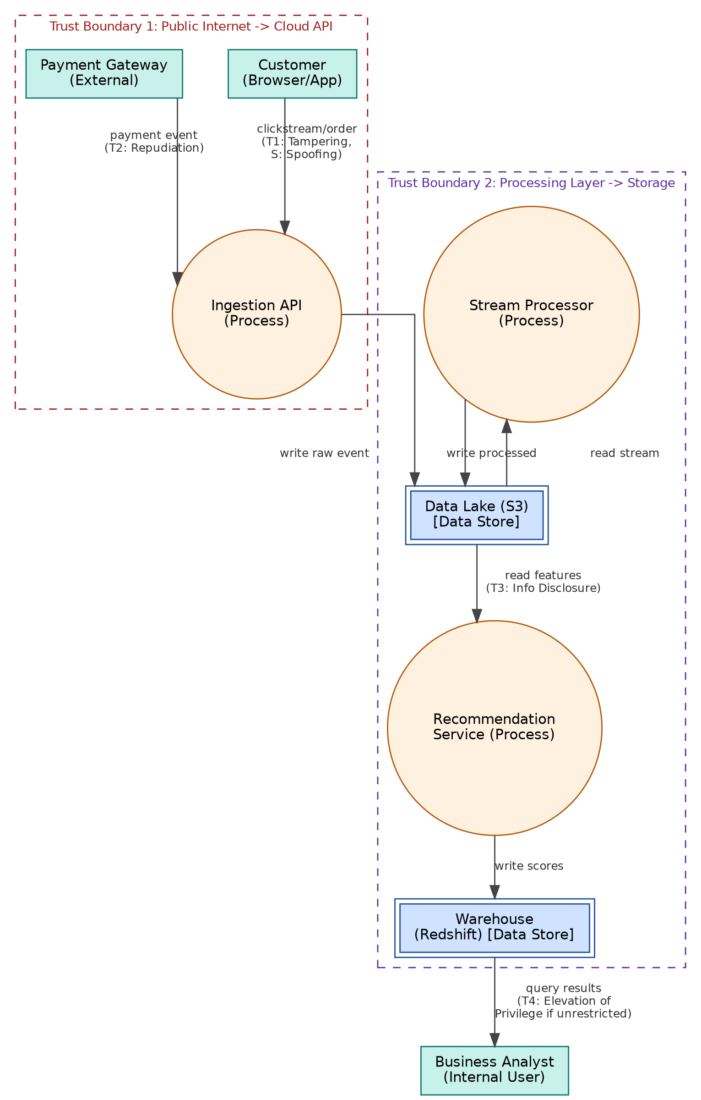

Guided Tool Module 4: Dashboard or Analytics Output Mockup
Purpose: Show how raw big data becomes useful decisions through a dashboard, alert, forecast, recommendation or report.
Beginner-Friendly Choice
Use any one: Power BI, Looker Studio, Tableau Public or Canva. If login/install is difficult, Canva dashboard mockup is acceptable. If data connection is possible, Power BI/Looker Studio/Tableau Public is stronger.
No. | Perform |  | Observe / Decide |  |  | Record in Workbook
1 | Prepare a small sample dataset in Excel or Google Sheets with 10-20 rows. |  | Columns should match your scenario. Example: timestamp, user/location, event type, value, status, risk level. |  |  | Paste column names.
2 | Choose the dashboard tool. |  | Power BI/Tableau/Looker are analytics tools; Canva is acceptable for visual mockup when live data connection is blocked. |  |  | Write chosen tool and reason.
3 | Import or recreate the sample data. |  | In Power BI/Looker/Tableau, connect data. In Canva, manually create charts from sample values. |  |  | Paste screenshot of data/chart setup.
4 | Create at least three visual elements. |  | Use KPI card, bar chart, line chart, table, map, alert count or pie/donut chart as appropriate. |  |  | List the visuals.
5 | Add decision labels. |  | A dashboard is useful only if it supports a decision: allocate beds, detect fraud, reroute buses, restock products, warn farmers. |  |  | Write decision supported by each visual.
6 | Export/share screenshot. |  | Paste the final dashboard screenshot or public/report link if available. |  |  | Paste evidence.
Dataset Column |  | Meaning |  |  | Example Value
timestamp |  | Date and time the event occurred |  |  | 2026-08-10 14:32:07
customer_id |  | Unique identifier for the customer/session |  |  | CUST_10432
event_type |  | Type of behavior captured |  |  | cart_add / checkout / abandon / purchase
product_category |  | Category of the product involved |  |  | Electronics
cart_value |  | Monetary value of the cart at the event |  |  | 82.50
conversion_status |  | Whether the session ended in purchase |  |  | converted / abandoned
Visual Element |  | Metric Shown |  | Decision Supported
KPI cards (Conversion Rate, Cart Abandonment, AOV, Active Sessions) |  | Real-time summary metrics for the current period. |  | Whether to launch an immediate promotional push if conversion is trending low.
Bar chart - Revenue by Category |  | Weekly revenue split across product categories. |  | Which category to feature in the next campaign or restock urgently.
Line chart - Daily Visitors with anomaly flag |  | Daily visitor volume with an automatic spike/anomaly marker. |  | Whether a traffic spike needs infrastructure scaling or signals bot/fraud activity.
Donut chart - Funnel Stage Share |  | Share of sessions at each funnel stage (browse, cart, checkout, purchase). |  | Which funnel stage to retarget with reminders or incentives.

Dashboard / Analytics Output Evidence
Type response / paste screenshot / paste diagram here.
Chosen tool: a self-generated dashboard mockup (matplotlib) representing what a Power BI / Looker Studio / Canva build would show, since live data-source login was unavailable in this environment. Reason: it lets me lay out the exact KPI cards, charts and decision labels required by the module without depending on an external account. Sample dataset columns are listed above; the mockup below uses illustrative values in that same schema.
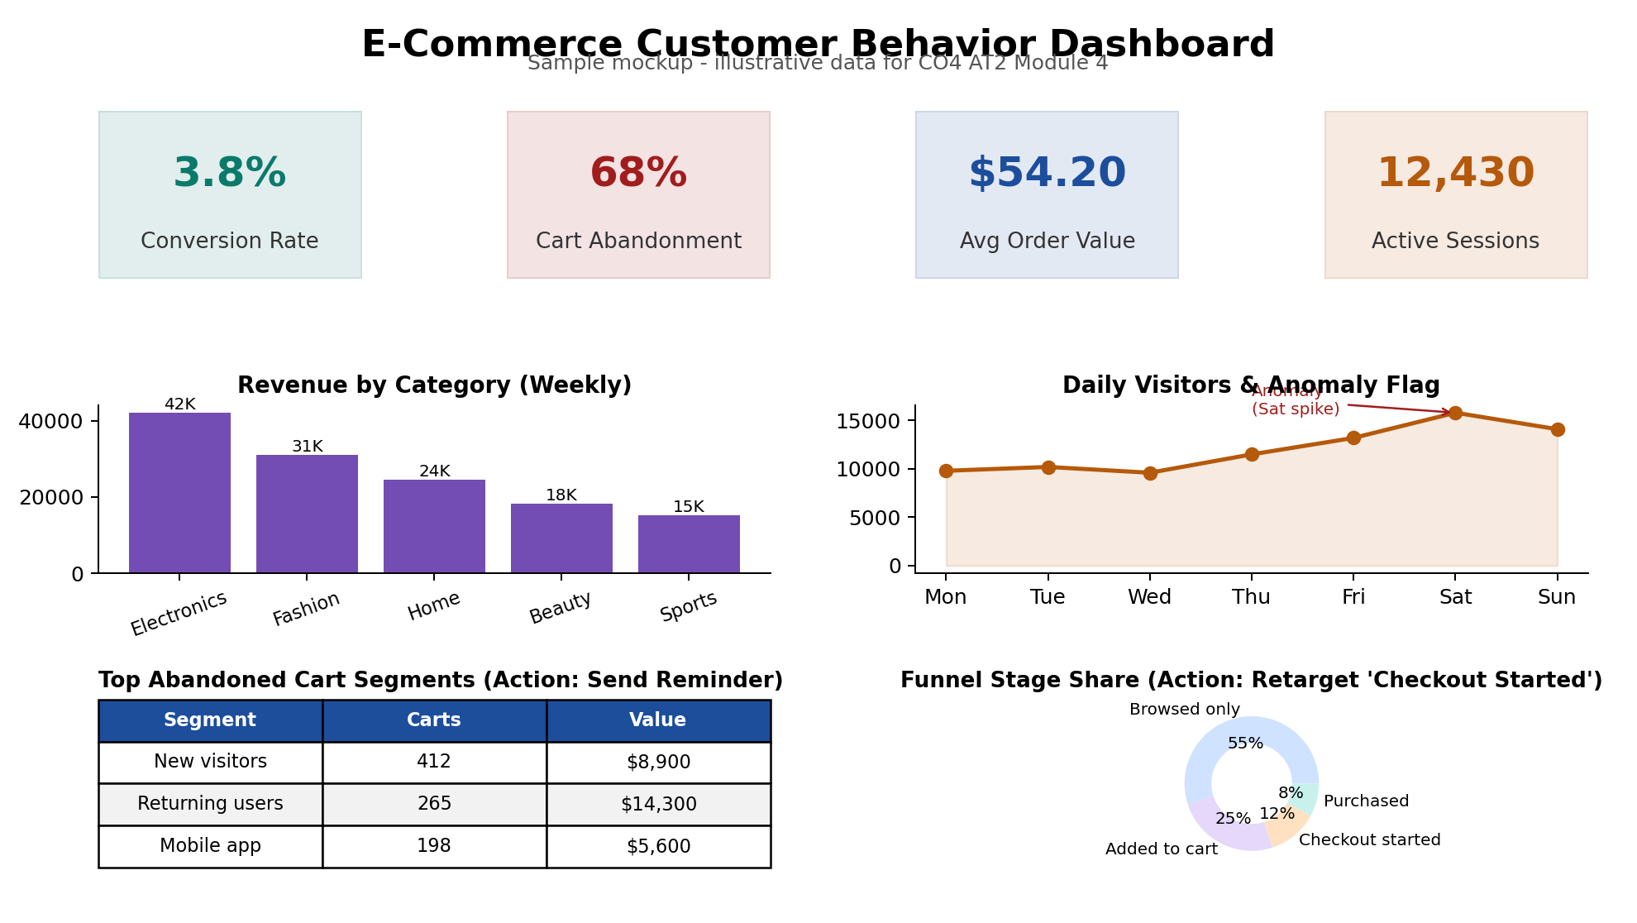

Final CO4 AT2 Solution Sections
Final Assembly
After completing the guided tool modules, combine the evidence into the final solution. The final answer must show technical reasoning, not only screenshots.

1. Problem Understanding
What to include: Identify stakeholders, decisions required, data produced, expected analytics output and urgency.

Student Response
Type response / paste screenshot / paste diagram here.
Stakeholders: e-commerce business analysts, marketing managers, and the platform/engineering team operating the capstone. Decisions required: which products to promote, when to send cart-abandonment reminders, how to allocate campaign budget, and when to investigate a traffic/fraud anomaly. Data produced: clickstream events, cart and checkout events, payment success/failure logs, campaign traffic logs, and historical order records. Expected analytics output: conversion and abandonment KPIs, revenue-by-category trends, funnel-stage breakdowns, and real-time anomaly/fraud alerts. Urgency: cart and payment-failure signals need near-real-time response (minutes), while revenue and funnel reporting can be reviewed on a daily/weekly batch cycle.

2. 5Vs Mapping
What to include: Map Volume, Velocity, Variety, Veracity and Value using scenario evidence.

Student Response
Type response / paste screenshot / paste diagram here.
Volume: tens of thousands of clickstream and order events per day across all customer sessions. Velocity: clickstream, cart and payment events arrive continuously and must be processed within seconds to minutes for timely reminders and fraud alerts. Variety: structured order/payment records, semi-structured clickstream/JSON events, and campaign traffic logs from multiple ad platforms. Veracity: clickstream data can include bot traffic, duplicate events or incomplete sessions, requiring cleaning and deduplication before it is trusted for decisions. Value: the platform converts raw behavioral data into concrete business actions - reminder emails, restocking decisions, campaign reallocation and fraud investigation - each tied to a measurable outcome.

3. Big Data Architecture
What to include: Paste final draw.io architecture showing sources, ingestion, storage, processing, analytics/security and users.

Student Response
Type response / paste screenshot / paste diagram here.

The architecture follows sources (website/app clickstream, order/payment system, campaign logs) -> ingestion (streaming via Kinesis for clickstream/campaign, batch extract for orders) -> storage (S3 data lake) -> processing (Spark Structured Streaming for real-time behavior, Spark/Hadoop batch for historical orders) -> analytics (Redshift warehouse and SageMaker recommendation/anomaly model) -> dashboard (BI tool) -> users (business analysts/marketing managers), with Cognito/IAM identity, encryption and CloudWatch audit logging applied across the ingestion and API layer.

4. Data Flow Pipeline
What to include: Explain how raw data moves, gets cleaned, stored, processed and converted into dashboard/alert/decision.

Student Response
Type response / paste screenshot / paste diagram here.
Raw clickstream and cart events are published to a streaming ingestion service the moment they occur on the website/app; campaign and order data are pulled in on a scheduled batch extract. Both paths land as raw objects in the S3 data lake. Spark Structured Streaming continuously cleans and deduplicates the live events, computing per-session cart-abandonment and anomaly signals within a sliding time window, and writes results back to S3 and forward to SageMaker for scoring. Nightly Spark/Hadoop batch jobs clean and aggregate the historical order data and load it into Redshift alongside the streaming-derived scores. The dashboard queries Redshift (and calls the SageMaker endpoint for the latest scores) to render KPI cards, charts and funnel views, while a separate alert path pushes cart-abandonment or fraud notifications directly to the marketing/analyst team as soon as the streaming job flags them.

5. Tool and Technology Justification
What to include: Use cloud architecture references and Hadoop/Spark documentation to justify chosen tools.

Student Response
Type response / paste screenshot / paste diagram here.
Kinesis/streaming ingestion and Spark Structured Streaming are justified by the AWS and Spark documentation's own guidance that continuously arriving, time-sensitive events (sensor/clickstream data) belong in a streaming pipeline rather than a batch job, which matches the cart-abandonment and fraud-alert requirements here. S3 as the data lake and Spark/Hadoop batch ETL for order history follow the same architecture-center pattern used across all three cloud providers for large, append-only, read-many datasets. Redshift and SageMaker were chosen over building custom infrastructure because they are the managed PaaS equivalents already justified in my CO2 AT3/CO1 AT2 service-model matrix, letting the team focus on schema design and model quality instead of database or ML-infrastructure operations.

6. Security and Privacy Strategy
What to include: Use threat model output to explain threats and controls.

Student Response
Type response / paste screenshot / paste diagram here.
The threat model in Module 3 identified six key risks spanning spoofing/tampering at ingestion, repudiation of payment events, information disclosure from the data lake and recommendation service, denial of service against the AI endpoint, and elevation of privilege at the dashboard layer. Controls: TLS and Cognito-JWT authentication on every ingestion and API call; IAM least-privilege policies plus encryption at rest on S3 and Redshift; PII masking/tokenization before storage; CloudWatch audit logging with alarms on error-rate and latency spikes; SageMaker endpoint autoscaling and request throttling to resist DoS; and Redshift role-based row/column security so analysts only see data within their assigned scope. Together these controls address each STRIDE category identified for this scenario without blocking the near-real-time alerting the business depends on.

7. Challenges and Solutions
What to include: Write at least four big-data implementation challenges and one practical solution for each.

Student Response
Type response / paste screenshot / paste diagram here.
Challenge 1 - Noisy/bot clickstream data: raw event volume includes bot traffic and duplicate sessions that distort conversion metrics. Solution: apply a streaming deduplication/bot-filtering step before events reach the analytics layer, using session fingerprinting and rate-based filtering. Challenge 2 - Balancing real-time and batch costs: running Spark Structured Streaming continuously is more expensive than batch. Solution: scope streaming only to the events that truly need low latency (cart/payment/campaign) and keep everything else on a cheaper nightly batch schedule. Challenge 3 - Cold-start recommendations for new customers: SageMaker's model has little behavioral data for first-time visitors. Solution: fall back to category-popularity-based recommendations until enough session data accumulates for a personalized score. Challenge 4 - Cross-team data access without over-exposure: analysts and marketing need different slices of the same warehouse. Solution: implement Redshift row/column-level security tied to Cognito roles so each team sees only what its role requires, rather than building separate databases.

8. Business Outcome
What to include: State measurable outcome: faster decision, reduced fraud, lower waiting time, improved prediction, lower downtime or better user experience.

Student Response
Type response / paste screenshot / paste diagram here.
Measurable outcome: faster, more targeted decisions - cart-abandonment reminders sent within minutes instead of the next business day, expected to recover a meaningful share of the current 68% abandonment rate; category and campaign spend reallocated within the same week based on the revenue-by-category and funnel-share views instead of end-of-month reporting; and earlier fraud/anomaly detection through the SNS+Lambda alert path, reducing the time between a suspicious spike occurring and an analyst being notified from days to minutes.

Rubric
Criteria | Marks | Evaluation Focus | Evidence
Problem and 5Vs analysis | 6 | Scenario-specific analysis and correct big-data reasoning | Workbook tables
Architecture and data flow | 6 | Correct pipeline, cloud components and flow clarity | draw.io diagram
Processing framework decision | 5 | Batch/streaming/hybrid justification using Hadoop/Spark concepts | Decision table
Security and privacy | 5 | Threat model, risks and controls | Threat model table/screenshot
Dashboard/output design | 4 | Useful decision-oriented analytics output | Dashboard/mockup
Clarity and submission quality | 4 | Organized, original, complete evidence | GitHub/GCR

Submission Checklist
- Student details and selected scenario are filled.
- Cloud architecture references are recorded.
- Hadoop/Spark processing decision is completed.
- Threat model diagram/table is included.
- Dashboard/mockup screenshot or link is included.
- Final solution sections are completed.
- DOCX/PDF and supporting files are uploaded to GitHub.
- GitHub repository link is submitted through Google Classroom.

Official Reference Links
AWS Architecture Center: https://aws.amazon.com/architecture/
Azure Architecture Center: https://learn.microsoft.com/en-us/azure/architecture/
Google Cloud Architecture Center: https://docs.cloud.google.com/architecture
Apache Hadoop MapReduce Tutorial: https://hadoop.apache.org/docs/stable/hadoop-mapreduce-client/hadoop-mapreduce-client-core/MapReduceTutorial.html
Apache Spark Structured Streaming: https://spark.apache.org/docs/latest/streaming/index.html
Microsoft Threat Modeling Tool releases: https://learn.microsoft.com/en-us/azure/security/develop/threat-modeling-tool-releases
OWASP Threat Dragon: https://owasp.org/www-project-threat-dragon/
Power BI documentation: https://learn.microsoft.com/en-us/power-bi/
Looker Studio create report: https://docs.cloud.google.com/data-studio/create-a-report
Tableau Public: https://www.tableau.com/community/public
Canva Charts: https://www.canva.com/help/charts/

